## Getting Up and Running with the Power BI Service

**Setup Time**: 60 minutes

**Lab Folder**: C:\Student\Modules\01_GettingStarted\Lab

**Overview**: This lab covers how to get up and running with Power BI by creating a new Office 365 tenant with trial subscriptions to Office 365 and Power BI Pro. The act of creating and configuring this new Office 365 tenant will yield an isolated testing and development environment for working on projects with the Power BI service and using Microsoft’s latest self-service BI tools such as Power BI Desktop and Microsoft Excel 2016. One valuable aspect of creating a new and isolated Office 365 tenant is that you will have tenant-level administrative permissions allowing you to configure the tenant with multiple user accounts for testing your Power BI projects in isolation from any existing Office 365 tenancy.

### Exercise 1: Create a new Office 365 Trial Tenant

In this exercise, you will create a new Office 365 tenant which allows you to create up to 25 user accounts with Enterprise E5 trial licenses. Note that the Enterprise E5 trial license provides the benefits of the Power BI Pro license. Being able to create multiple Office 365 user accounts in your Power BI testing environment will be important so that you can test the effects of sharing Power BI dashboards between users.

1. Navigate to the following URL:

<https://go.microsoft.com/fwlink/p/?LinkID=698279&culture=en-US&country=US>

1. Fill out the form with your personal information and click **Next**.

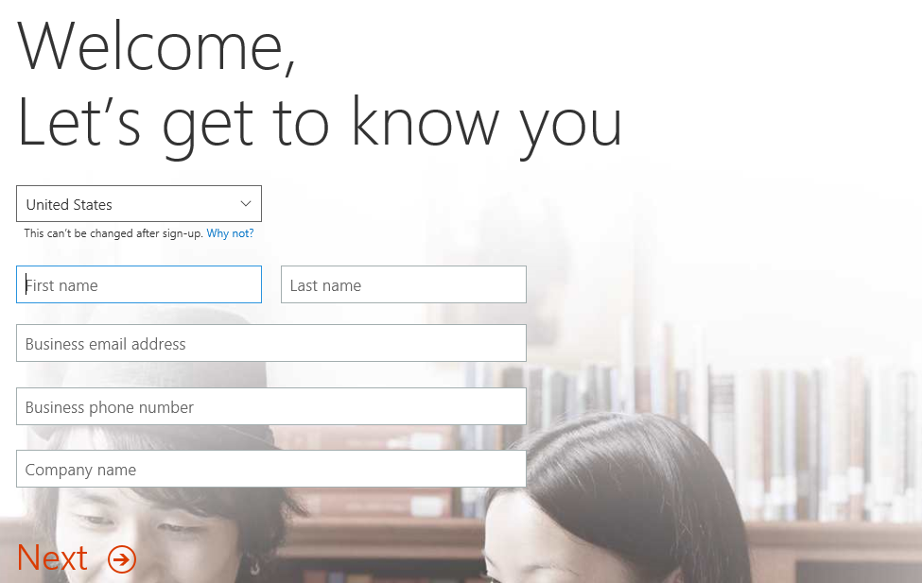

The information you provide here will be used throughout your tenant so if you do not wish to use your actual company name then provide humorous and fictitious company name. The name you use for company name will turn out to be the name of the trial Office 365 tenant that you are creating.

1. On the next page, you are prompted to provide a user ID, company name and password.

Note that the company name you enter on this page will be used to create the domain name for your new Office 365 trial tenant. For example, if you were to enter a company name of **CptPowerBiTenant**, it would result in the creation of a new Office 365 tenant within a domain of **CptPowerBiTenant.onMicrosoft.com**. The user name you enter will be used to create the first user account which will be given administrative rights within the trial tenant. If you enter a user name of **Student**, then the email address as well as user principal name for this account will be **Student@CptPowerBiTenant.onMicrosoft.com**.

1. Enter a user name and a company name for your new Office 365 trial tenant. For the company name, you may wish to simply use your first and/or last name with a number which you can increment each time you have to create a new trial account (e.g. EricClapton1.onmicrosoft.com).

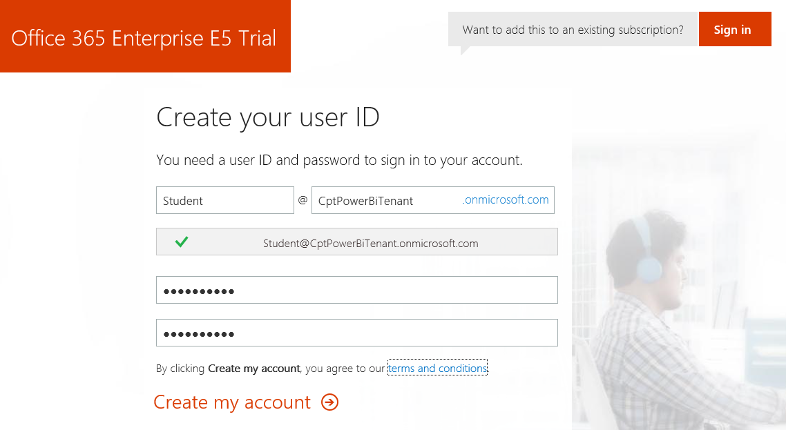

Don’t use your actual company name as that may cause some conflict when your company decides to create their own official tenant. Throughout the remainder of this guide you will see a company domain name of **CptPowerBiTenant** which you should replace with the value specified for your company name.

1. Click **Next** to continue to step 3.
2. Complete the validation form in step 3 by proving you are not a robot.
   1. Select the **Text me** option and provide the number of your mobile phone.
   2. When you go through this process, a Microsoft service will send you a text message that contains an access code.
   3. You retrieve the access code form your mobile device and use it to complete the validation process.



1. Once you have completed the validation process, click the **You’re ready to go…** link to navigate to the portal welcome page for your new Office 365 trial tenant. Note that you should already be logged on using the user account that was created during the sign up process.

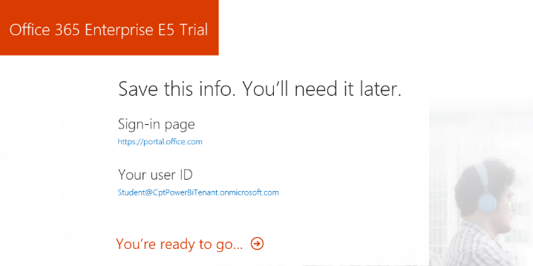

At this point, you have already created your new Office 365 tenant which can support creating up to 25 user accounts with Office 365 Enterprise E5 trial licenses. Note that some Office 365 services within your new Office 365 tenant such as the Office 365 admin center can be accessed immediately. Other services within your Office 365 tenant such as SharePoint Online are not ready immediately and will take some time to provision.

1. At this point, you should be located on the portal welcome page of Office 365. You will notice that this page shows the progress of the Office 365 environment in setting up each of the individual services that make up your new Office 365 tenant. Click the **Admin** tile to proceed to the Office **365 admin center**.

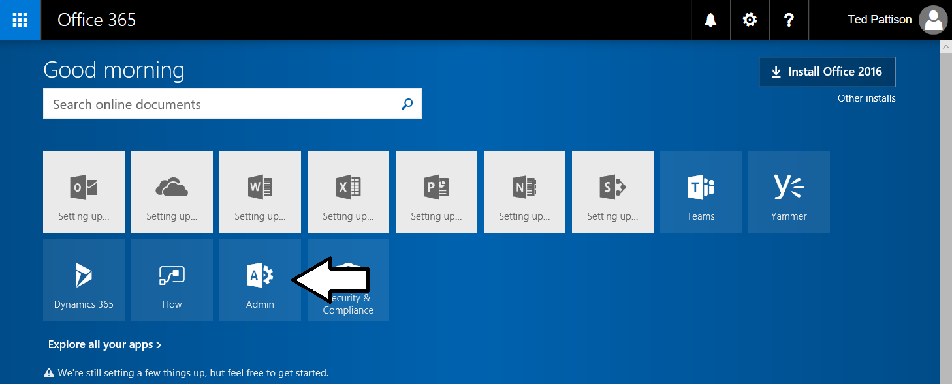

1. If you are presented with the Office 365 admin center welcome dialog, close it by clicking the **X** menu in the upper right corner.

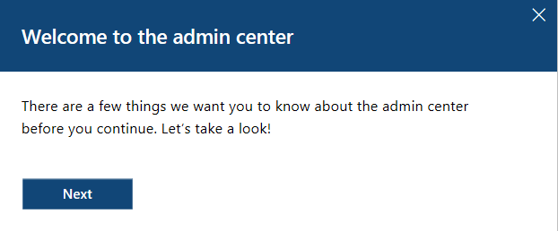

1. Verify that you are able to access the home page of the **Office 365 admin** **center**.
   1. The following screenshot shows the Office 365 Admin home page.

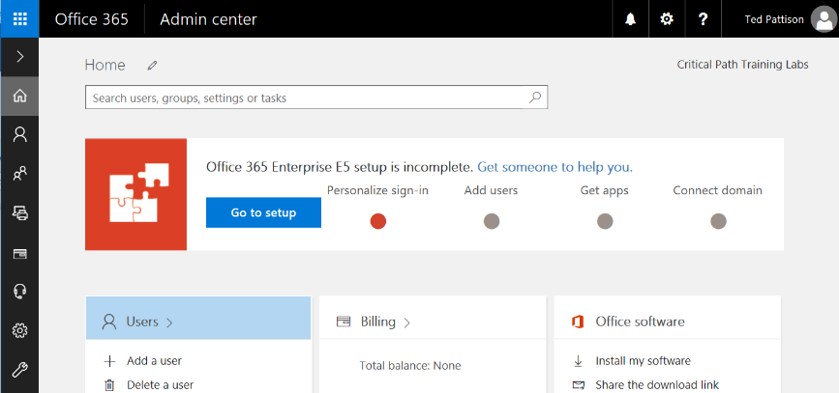

* 1. Locate the top **Menu** button for the left navigation menu. It’s the second button from the top with the arrow icon which sits just beneath the Office 365 App Launcher menu button.

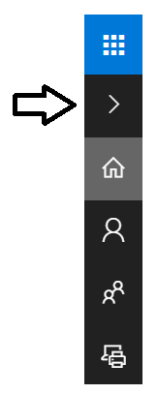

* 1. Click the top **Menu** button several times and see how it toggles the left navigation between a collapsed and expanded mode.

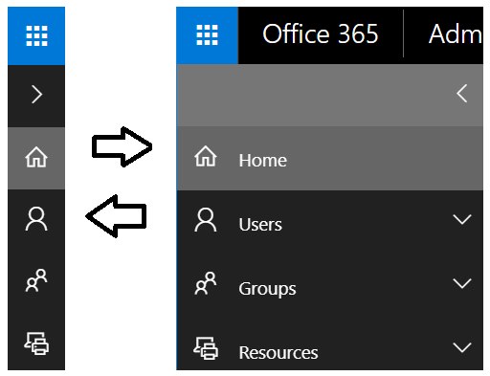

If you are interested in getting more familiar with the **Office 365 admin center**, take a minute to explore the administrative pages behind the left navigation menu in the Office 365 admin center.

### Exercise 2: Add a Secondary User Account for Testing Purposes

In this exercise, you will configure your new Office 365 tenant by creating a secondary user account that you will need later when you begin experimenting with the Power BI dashboard sharing process.

1. Make sure you in the browse at the home page of the Office 365 admin center.
2. Inspect the set of Active Users in the current tenancy.
   1. In the left navigation menu, expand the **Users** node and click **Active Users** to navigate to the **Active Users** page.

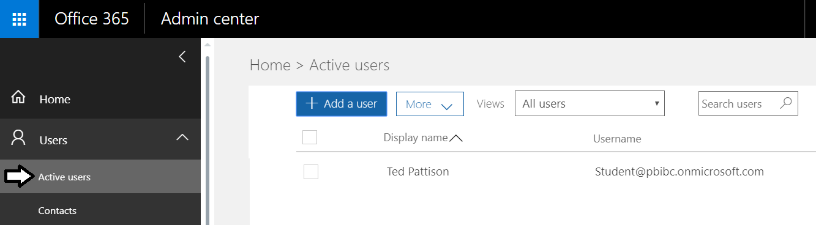

* 1. Once the **Active Users** page is displayed, you should be able to verify that the user account you are currently logged on as is the only user account that exists in the current tenancy. Remember that this account has been set up as a Global Administrator to the tenant because it is the account that was used when creating the tenant.

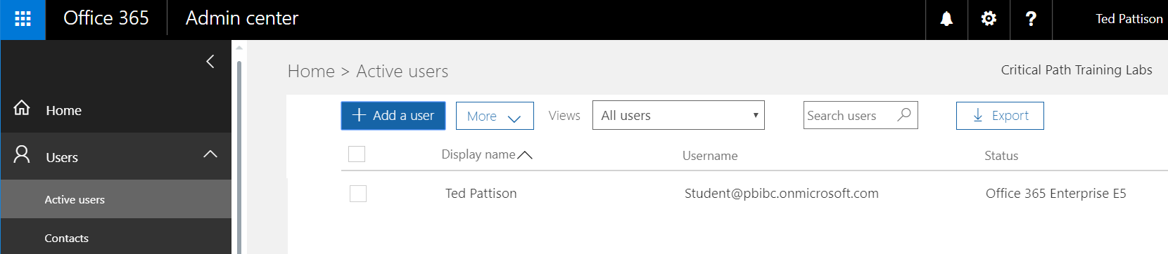

1. Create a new user account.
   1. On the **Active Users** page, click the button **Add a user** button to create a new user account

. 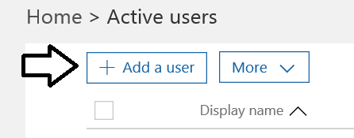

* 1. Fill in the **Create new user account** form with information for a new user account. When creating this account, you can use any name you would like. These lab instructions will demonstrate this by creating a user account for a person named **James Bond** with a user name and email of **JamesB@CptPowerBiTenant.onmicrosoft.com**.

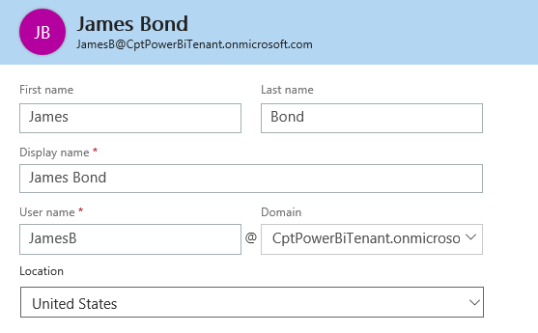

* 1. Expand **Password** section under **Contact Information** section.
     1. Select the option for **Let me create the password**.
     2. Enter a password of **pass@word1** into the textboxes labeled **Password** and **Retype** **Password**.
     3. Uncheck the checkbox for the option labeled **Make this user change their password when they first sign in**.

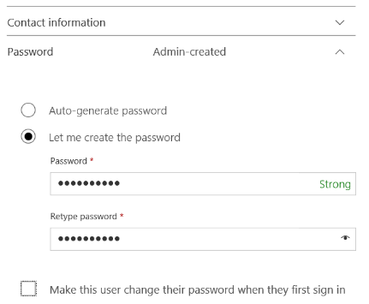

* 1. Expand the roles section. You do not need to change anything in this section, although you should note that this new user account will be created as a standard user account without any administrator access or privileges.

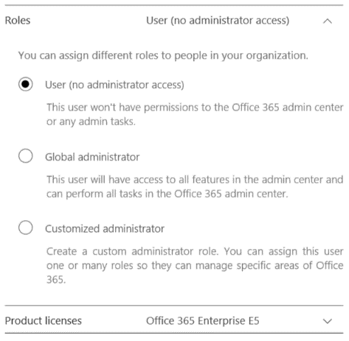

Note that the new account has been automatically assigned trial license for **Office 365 Enterprise E5** plan. That means you do not need to do anything further to enabled support for Power BI. Having the for **Office 365 Enterprise E5** license provides the same level access as a **Power BI Pro** license.

* 1. Click the Save button at the bottom of the new user form to create the new user account.

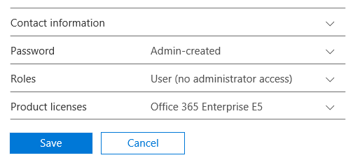

* 1. When you see the **User was added** message, click **Send email and close** to dismiss the **Add new user** task pane.
  2. Verify that the new user account has been created and is displayed along with your primary user account.

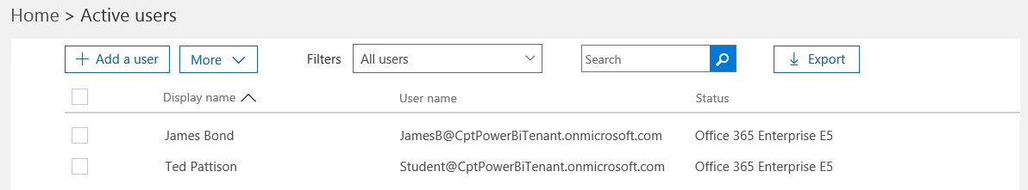

### Exercise 3: Getting Started with Power BI Desktop

In this exercise, you will first download and install Power BI Desktop if you have not already done so. Note that if Power BI desktop is already installed on your student workstation, you can skip ahead in this exercise to step 12.

1. Using the browser, navigate to the landing page of the Power BI service at <https://app.powerbi.com>.
2. On the top right of the Power BI service window, drop down the **Downloads** menu and click the **Power BI Desktop** menu command to begin the download of the installation file.

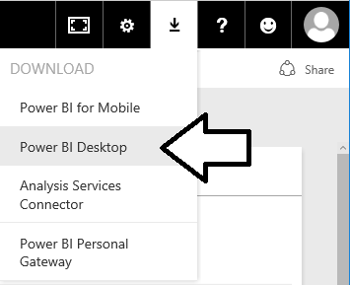

1. Wait for the MSI file to download.



1. Once the file has downloaded, click the **Run** button to begin the installation of Power BI Desktop.



1. When you see the Welcome screen, click **Next** to continue with the installation.

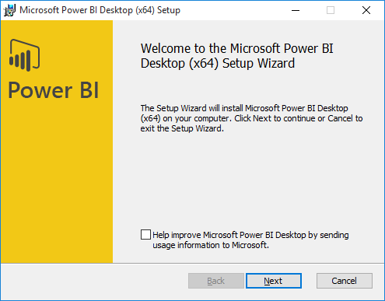

1. Click the checkbox to accept the license agreement and click **Next**.

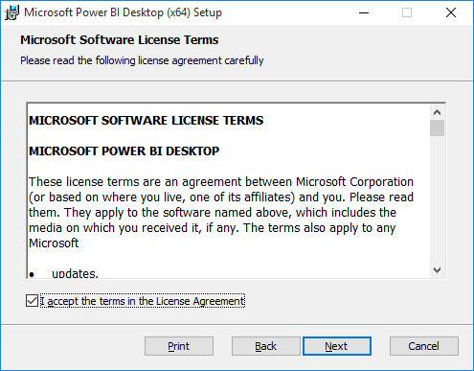

1. Accept the default location for the installation and click **Next**.

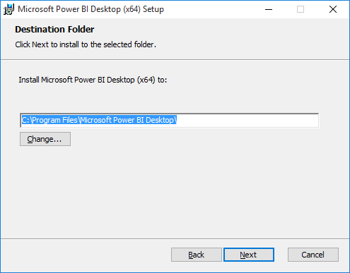

1. On the next screen, click **Install**.

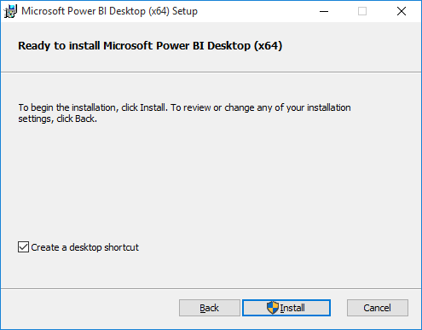

1. When you see the **Completed the Microsoft Power BI Desktop Setup Wizard** screen, click **Finish** to launch Power BI Desktop.

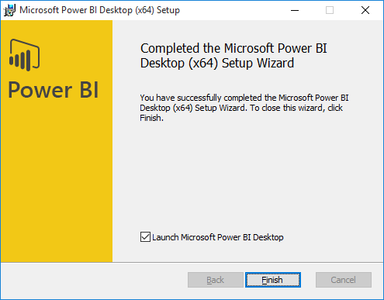

1. When Power BI Desktop launches for the first time, it displays a Welcome screen as shown in the following desktop. Click the (**X**) button in the upper right corner to close this window.

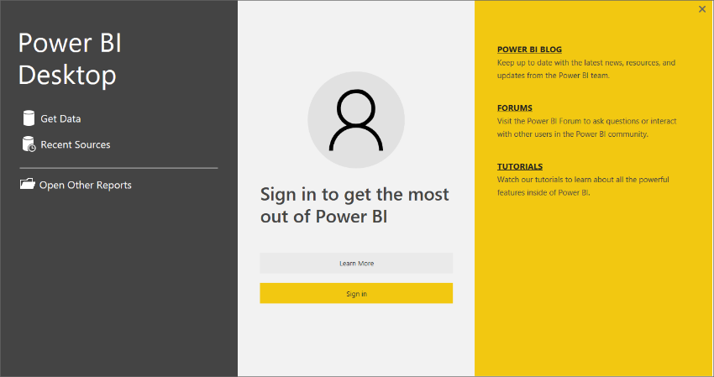

1. At this point, you should have Power BI Desktop running with a new, unsaved project as shown in the following screenshot.

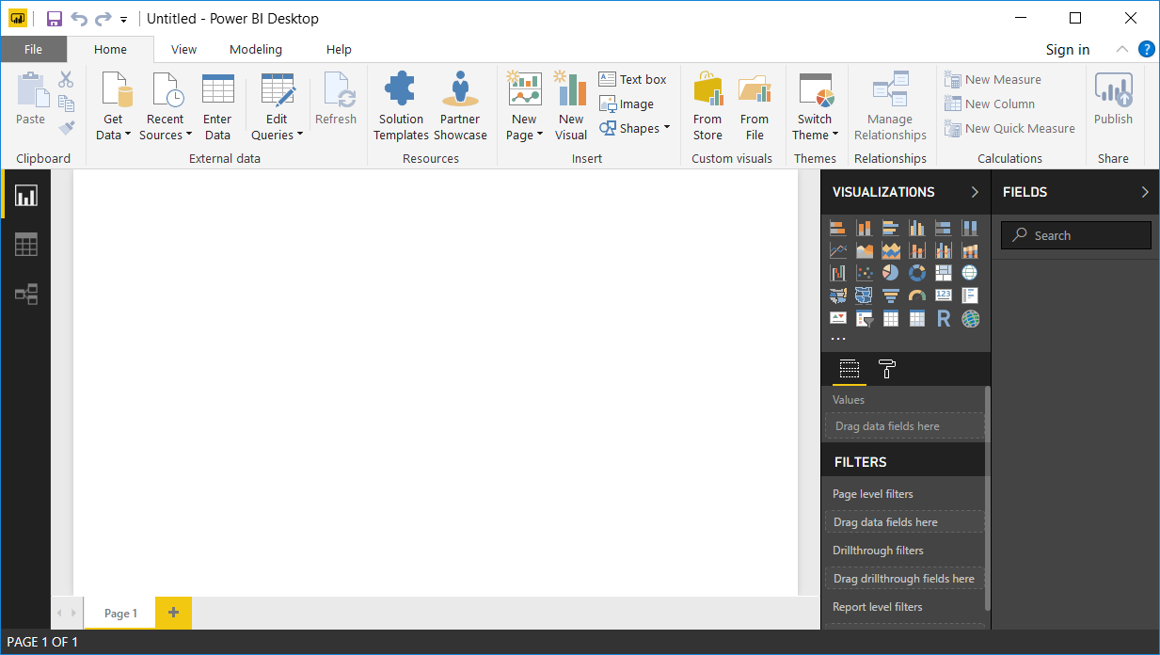

You can start this exercise here if Power BI Desktop was already installed.

1. Open the Power BI Desktop project file named **Lab01.pbix**.
   1. Select he **File > Open** command from within Power BI Desktop.

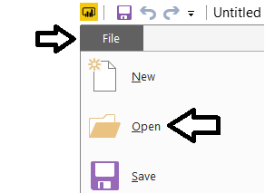

* 1. Locate the PBIX file located at the following path.

C:\Student\Projects\Wingtip Sales Analysis.pbix

* 1. Open **Lab01.pbix** to load this project into Power BI Desktop.

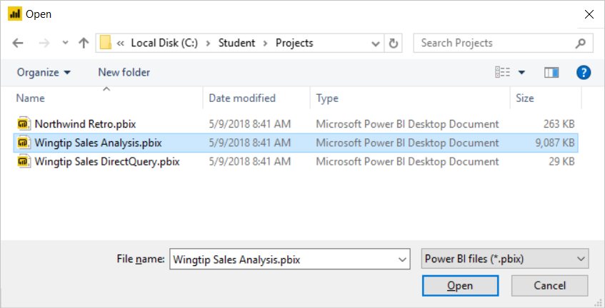

The project should now be open in Power BI desktop.

1. Inspect the contents of the Power BI Desktop project named **Lab01.pbix**.
   1. Inspect the report that has been created inside this project. You should see if provides four pages.

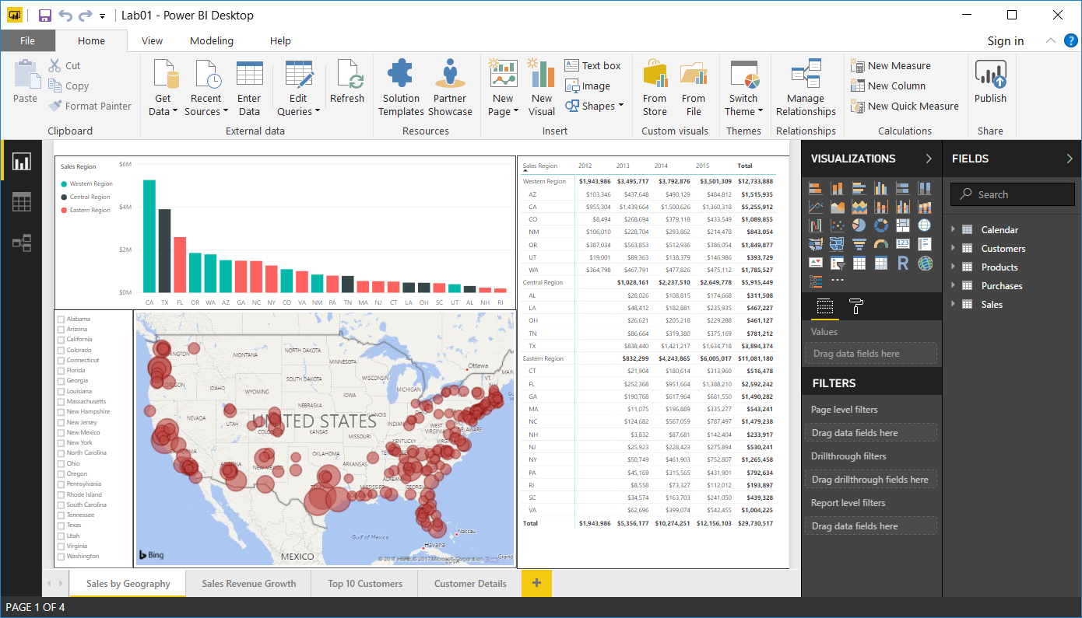

* 1. Using the navigation tabs at the bottom of the report, move from page to page to inspect each page in the report.

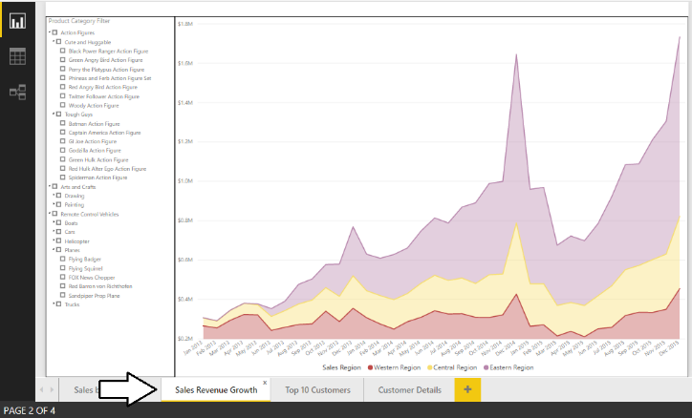

* 1. Click on the Relationship view button in the left navigation to see the tables included in data model and their relationships.

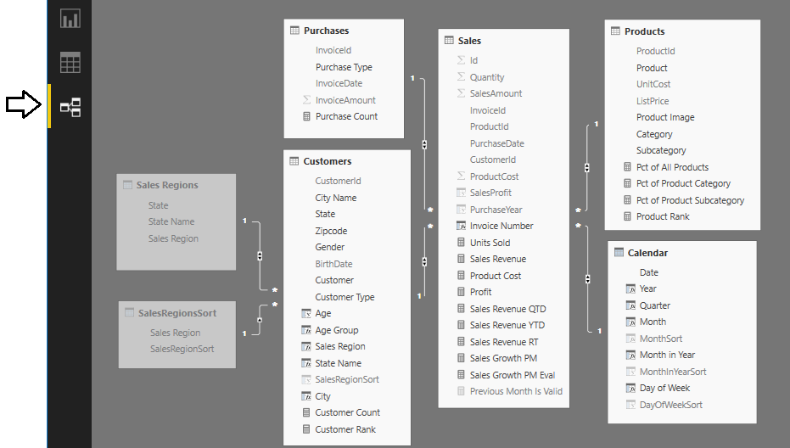

* 1. Click on the Data view button in the left navigation to see a tabular view of the data inside the project’s data model. Note that you can select a table in the FIELDS list on the right to see the data in that table.

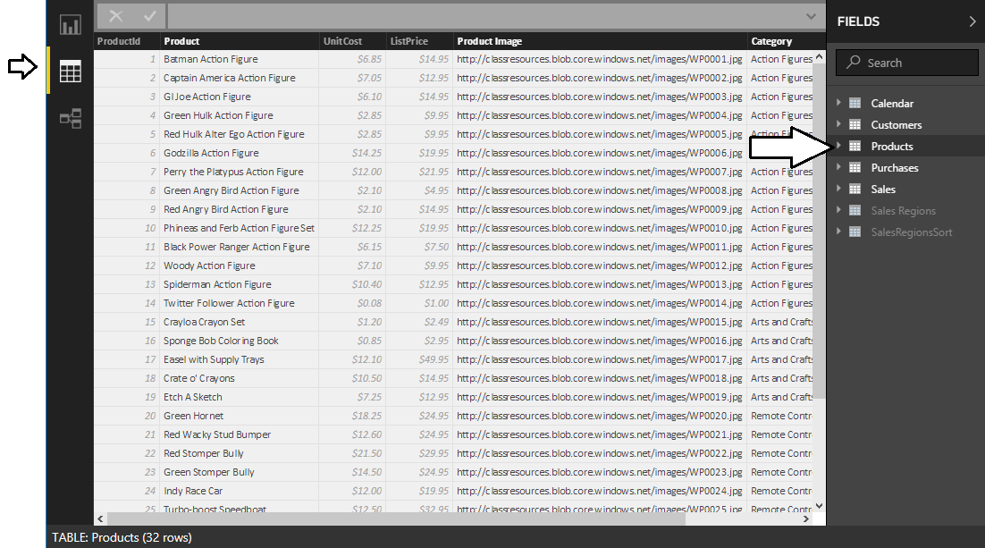

You do not need to make any changes to the Power BI Desktop project named **Lab01.pbix**. The purpose of this lab is for you to open an existing project that has already been completed and then to publish it to your personal workspace.

1. Publish the **Lab01.pbix** project to the Power BI Service.
   1. Navigate to the **Home** tab in the ribbon and click the **Publish** button on the far right-hand side.

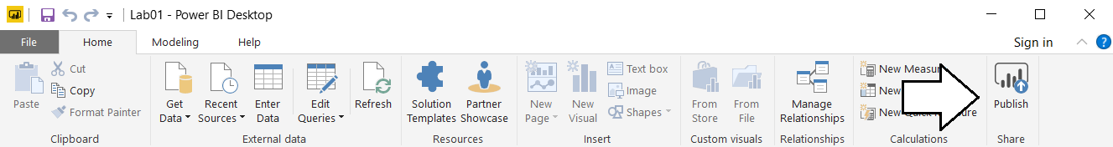

* 1. When promoted with the **Sign in to Power BI** dialog, click the **Sign In** button

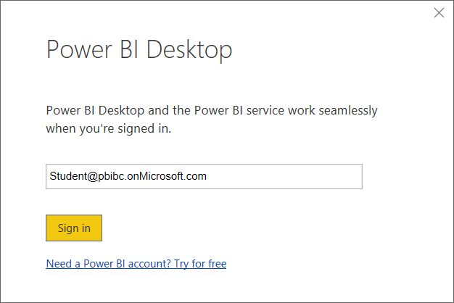

* 1. When prompted for your password, sign into the Power BI service.
  2. When Power BI Desktop prompts you with the **Publish to Power BI** dialog, select **My workspace** and then click **Select**.

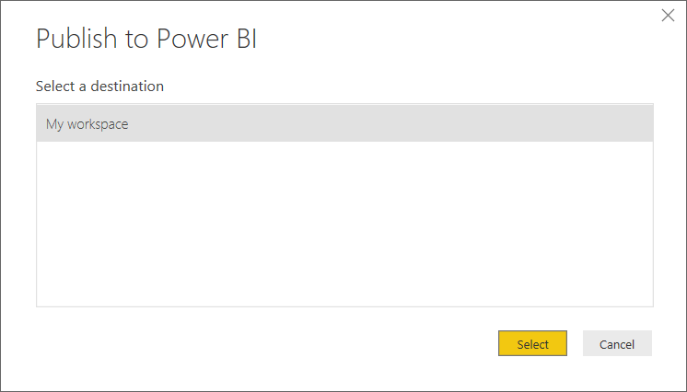

* 1. Power BI Desktop will display the **Publishing to Power BI** dialog as the publishing process begins.

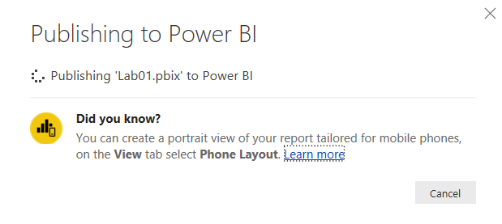

* 1. Once the publishing process has completed, the **Publishing to Power BI** dialog will display a success message and provide you with a link to **Open Lab01.pbix in Power BI**. Click on that link to navigate to the Power BI service using the browser.

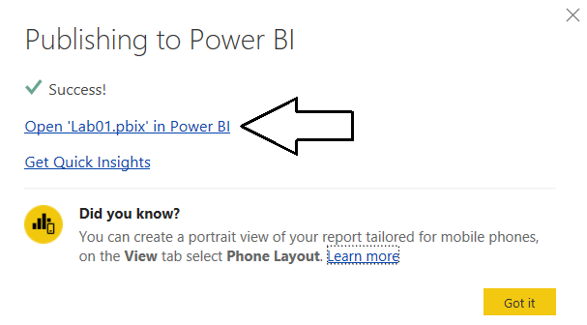

* 1. You should now be able to see the **Sales by Month** page of the report you just created.

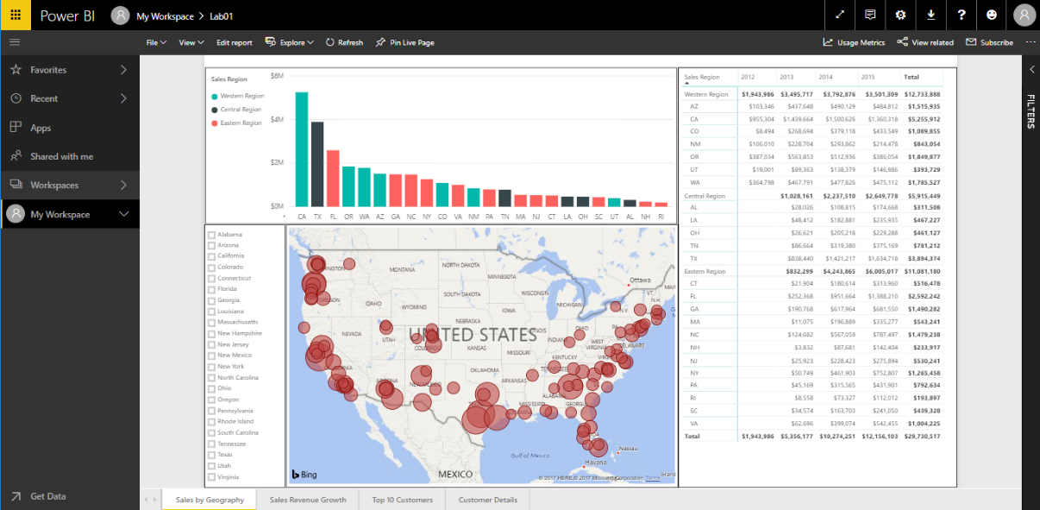

* 1. Click on the **Sales by State** link at the bottom of the screen to see the second page of the report.

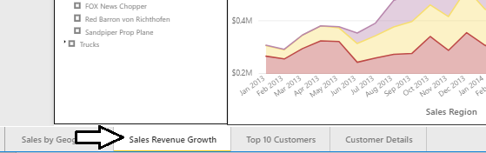

You have now successfully published a PBIX project using Power BI Desktop. But what happens when you want to make a change to a report after it has been published? It’s very easy because you can make changes to your Power BI Desktop project and republish it on top a previous version of the same project that has already been published.

1. Change the type of the visual that displays sales revenue by month and purchase type.
   1. Return back to Power BI Desktop and make sure you are in report view for the project named **Lab01.pbix**.
   2. Return to the **Sales by Geography** page.
   3. Select the **Map** visual.

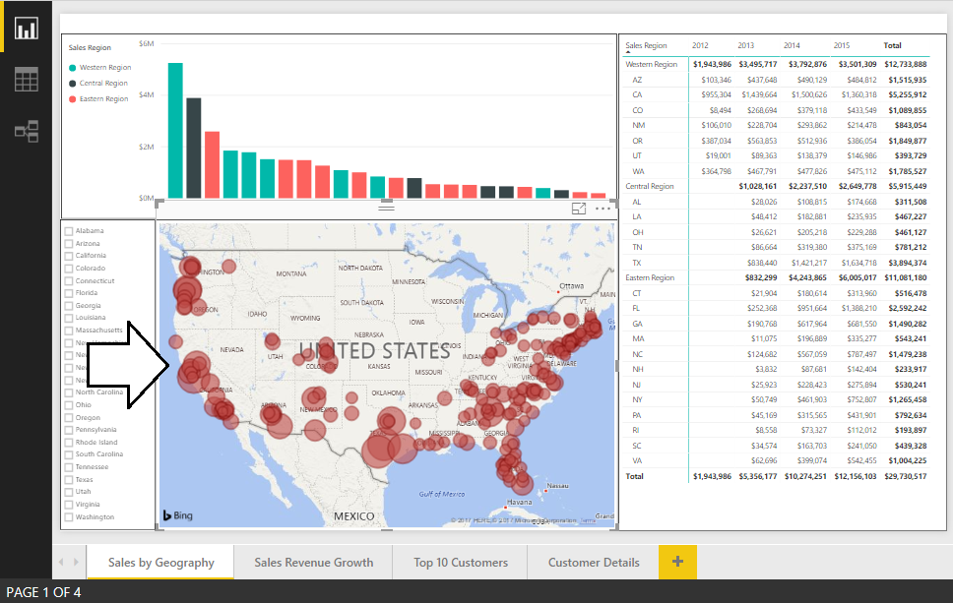

* 1. Update the **Default color** property in the **Data colors** section in the **Format pane** to change the color of the bubbles from red to a different color such as yellow or purple.

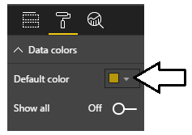

* 1. Verify that the bubbles in the Map visual are now a different color than red.

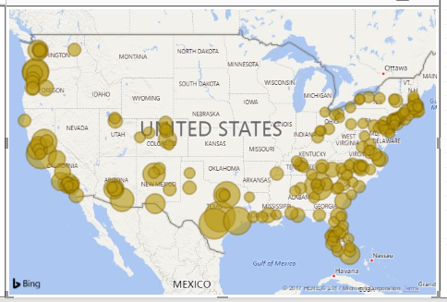

* 1. Save your changes to **Lab01.pbix**.

1. Republish the project to the Power BI service.
   1. Click the **Publish** button on the far right-hand side of the **Home** tab in the ribbon.
   2. When Power BI Desktop prompts you with the **Publish to Power BI** dialog, select **My workspace** and then click **Select**.
   3. When prompted with the **Replacing dataset** dialog, click Replace to begin the publishing process.

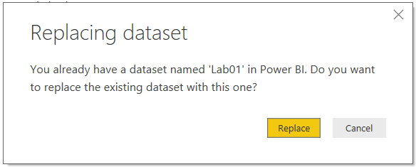

* 1. Once the publishing process has completed, inspect the published report in the Power BI service using the browser. Verify that the bubble color within the Map visual has been updated.

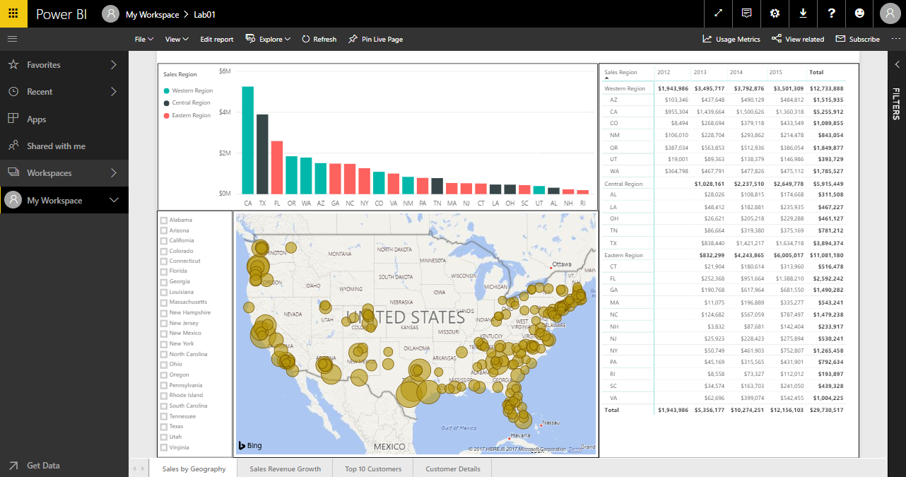

Congratulations, you have now finished this lab. If you finish early before other student and you still have extra time, experiment by clicking the **Edit report** button in the browser and seeing how you can continue to modify the pages of the report after the report has been published to the Power BI service. Note that any changes you make to the report through the browser will be overwritten if you republish the report with Power BI Desktop.